edgar6_check

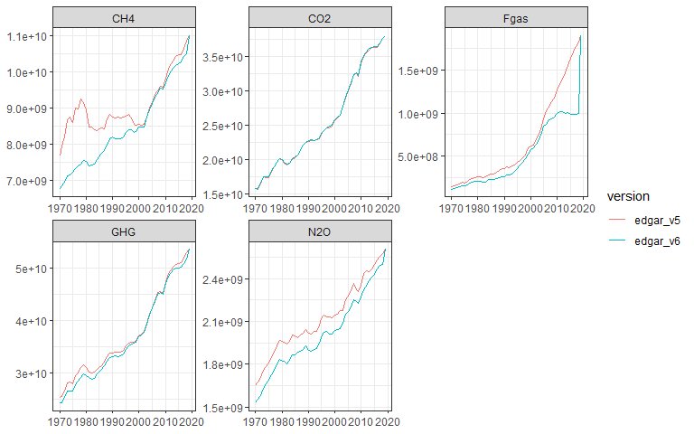

## `summarise()` has grouped output by 'year'. You can override using the `.groups` argument.

## geom_path: Each group consists of only one observation. Do you need to adjust  
## the group aesthetic?  
## geom_path: Each group consists of only one observation. Do you need to adjust  
## the group aesthetic?

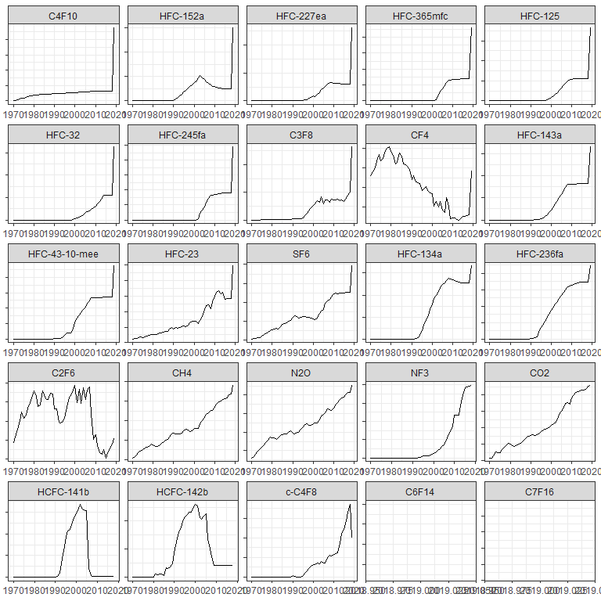

## `summarise()` has grouped output by 'year', 'sector_code', 'fossil_bio'. You can override using the `.groups` argument.

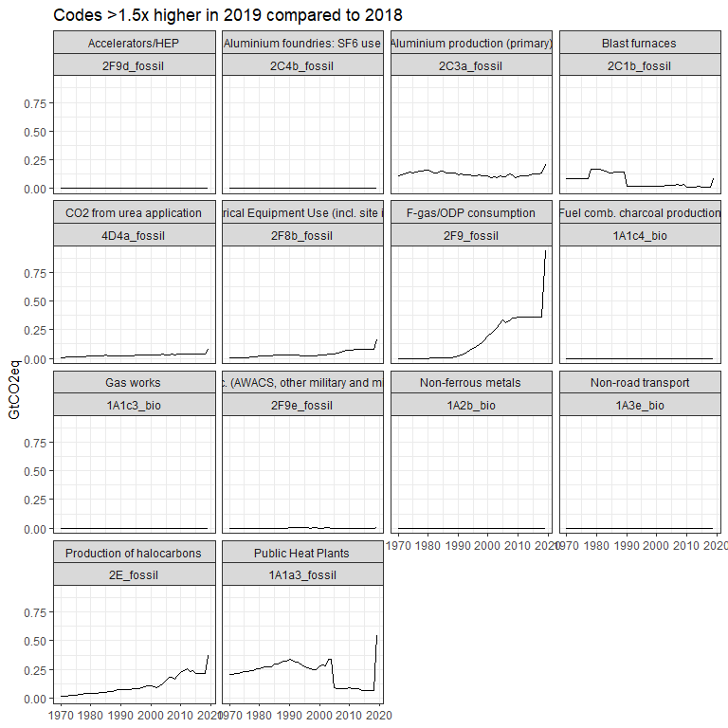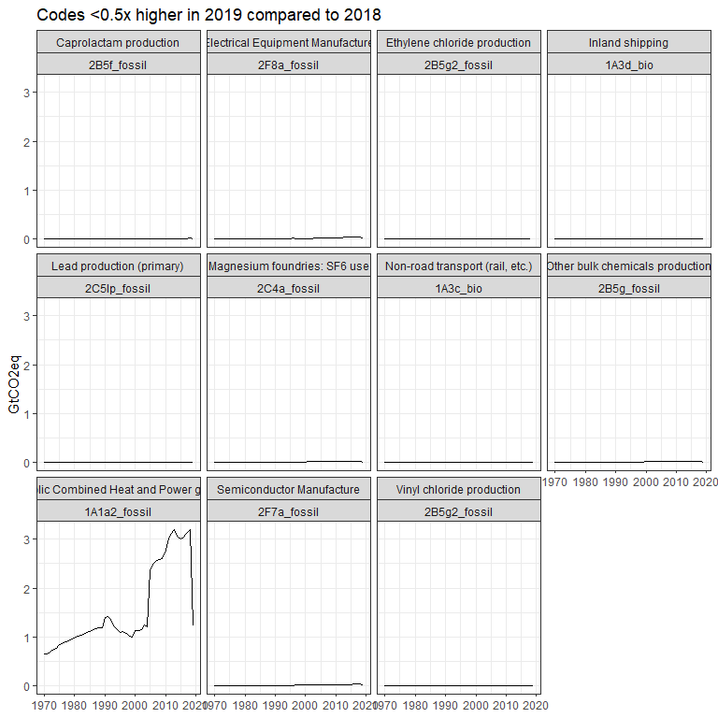

## `summarise()` has grouped output by 'year'. You can override using the `.groups` argument.

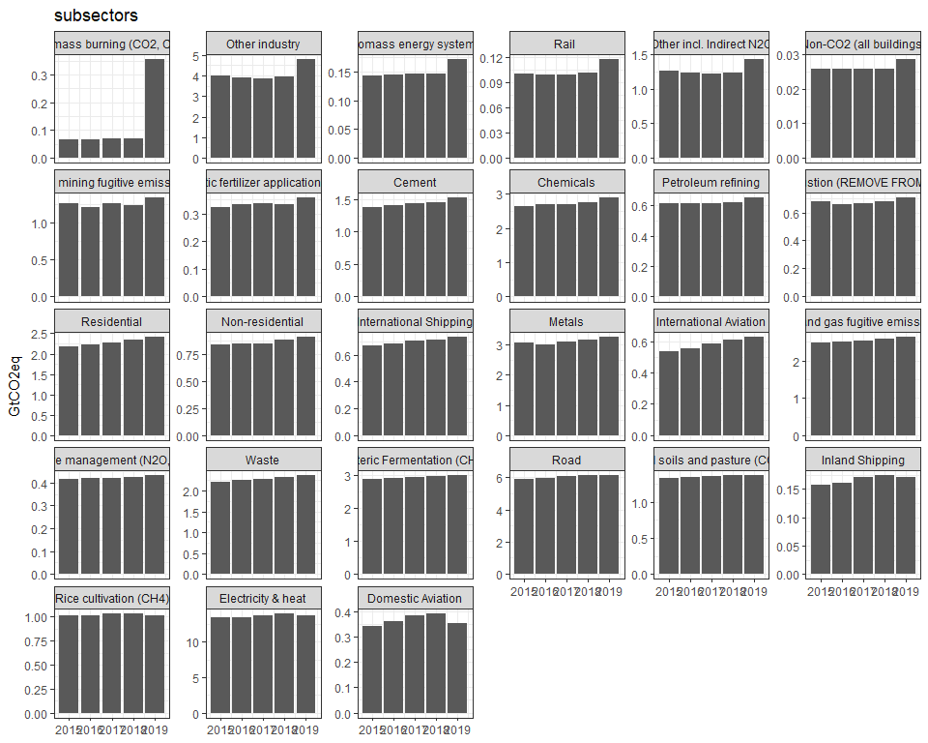

## `summarise()` has grouped output by 'year'. You can override using the `.groups` argument.

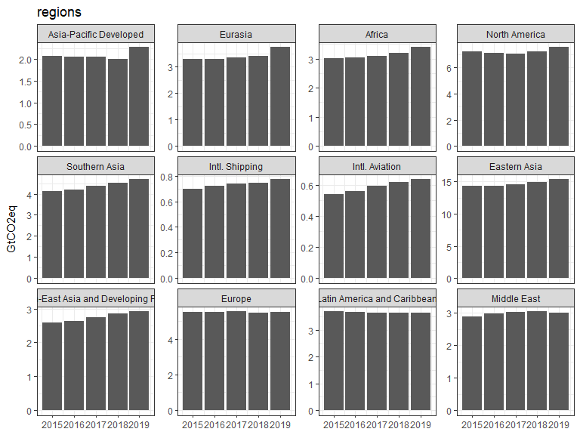

## `summarise()` has grouped output by 'year'. You can override using the `.groups` argument.

